Prof. Dr.-Ing. Heinz Pitsch

Templergraben 64
52056 Aachen
phone +49 241 80 94607
fax +49 241 80 92923
email office@itv.rwth-aachen.de

Stand: 29.06.2022

Bachelor- / Masterarbeit
Development of data-driven emission correlations for
sustainable aviation fuels

The use of sustainable alternative aviation fuels, so-called "Sustainable Aviation Fuels (SAF)", is an important step towards environmentally friendly aviation. In order to efficiently design aircraft engines for SAF, it is necessary to be able to concurrently evaluate the potential and effects of different alternative fuels and fuel mixtures already in early development phases. A key aspect here is the estimation of the formation of undesirable pollutant emissions such as NOx and unburned hydrocarbons (uHC). For conventional kerosene, correlation formulae for so-called emission indices have been established, which were mostly derived by means of semi-empirical considerations. These include, for example, terms for global reaction rates (e.g. of thermal NO production), whose parameters, however, were determined empirically on the basis of available emission measurements for conventional fuels such as kerosene in real gas turbines or aircraft engines. As a result, their applicability to alternative fuels is very limited.

In order to be able to take alternative fuels into account in engine design, new emission correlations for alternative aviation fuels are to be developed in this work. The work is integrated in a current research project, which is carried out at the ITV, and is therefore of high relevance. Depending on the interest, the focus of the work can be determined individually.

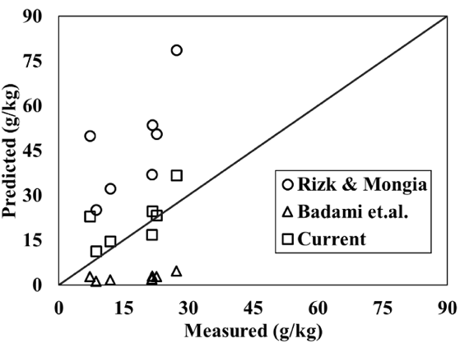
Your Tasks
Literature research on available correlations for conventional fuels as well as emission data for SAF.
- Development and validation of new correlations for NOx and uHC emissions for SAF
- Application of novel tools (e.g. neural networks)

Your requirements
- High motivation and independent working style
- Interest in aviation fuels, sustainability, combustion and modeling
Beispiel:
Combustion and Emission Characteristics from Biojet Fuel Blends in a Gas Turbine Combustor
(Sundararaj et al., 2019)

Our offer
- Collaboration in current, highly relevant research projects
- Possibility to take up a corresponding HiWi job if applicable

Contact person
Sanket Girhe
Tel. +49 241 80 94613
s.girhe@itv.rwth-aachen.de

If interested, please send a brief resume and grade transcript!

